Australian War Graves
in Durrington Cemetery, Wiltshire
World War 1

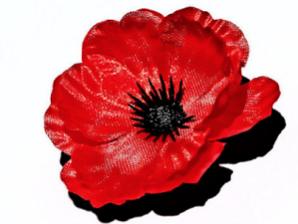
Lest We Forget

Surnames between | Website Link
A - C | https://ww1austburialsuk.weebly.com/a---c1.html
D - G | https://ww1austburialsuk.weebly.com/d---g2.html
H - J | https://ww1austburialsuk.weebly.com/h---j.html
K - Mc | https://ww1austburialsuk.weebly.com/k---mc.html
Me – Q | https://ww1austburialsuk.weebly.com/me---q.html
R - S | https://ww1austburialsuk.weebly.com/r---s1.html
W - Y | https://ww1austburialsuk.weebly.com/w---y.html

The biographies for the Australian WW1 War Graves are located on the website
“WW1 Australian Soldiers & Nurses Who Rest in the United Kingdom”

The links above have been used with permission of the Webowner – Beth Page of South Australia.

