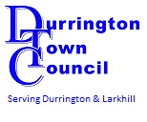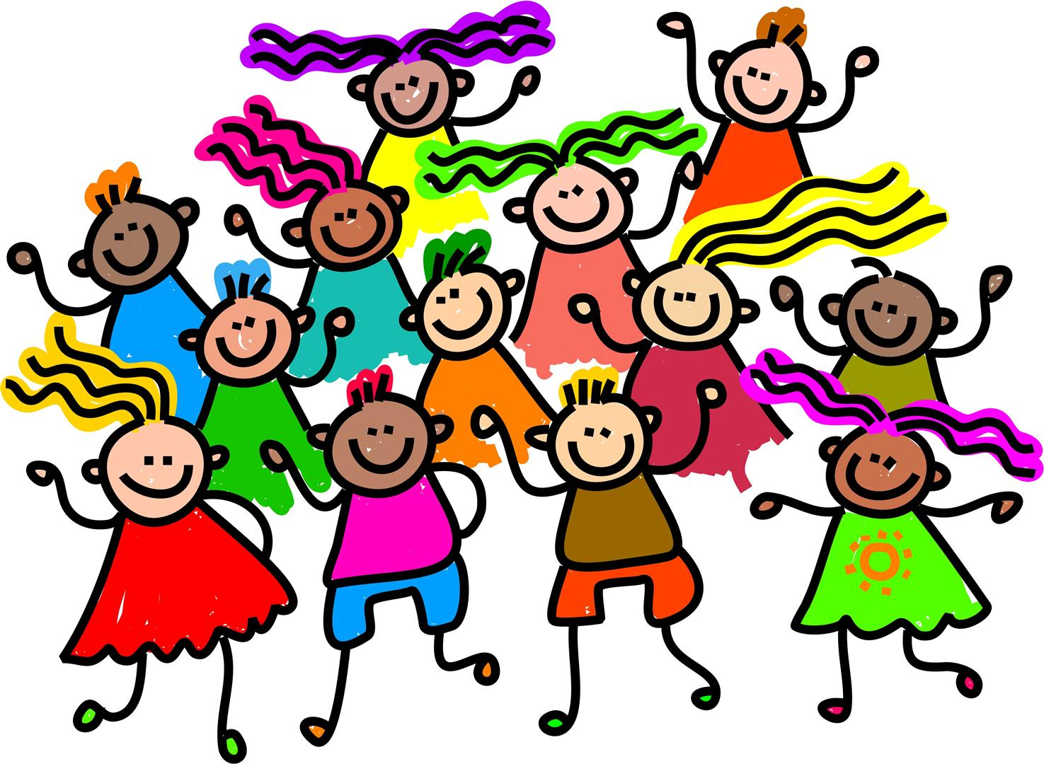  Kids Fun Club | Kids Fun club is a free youth club provided by Durrington Town Council for children in year groups 3 – 6.  Come along and join in the fun on Fridays 6pm -7.30pm, term time only.
 | Board Games  Football Table  Air Hockey  Pool Table  Arts and CraftsMusic Football  Use of recreational facilities  Tuck bar and more!
The Jubilee Pavilion, Recreation Road, Durrington.
For more info contact; Town Council Office 01980654772
Or email the club manager; Durringtonyp@outlook.com

