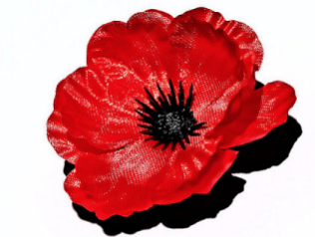 Durrington Cemetery War Graves

Canadians
Surname | First Names | Rank | Service No. | Served With | Died | Died of | Grave Location in Durrington Cemetery
Burnett | George | Sapper | 45059 | Canadian Engineers | 6 Dec 1914 | Pneumonia  In Hospital | Plot 49
Marchbank | Ogilvie James | Lieutenant |  | Canadian Engineers | 2 Jun 1918 | Burns – Aero Accident  Military Hospital, Fargo, Wiltshire | Plot 284
Barker | Joseph Claude | Second Lieutenant |  | Royal Air Force | 19 May 1918 | Aero Accident | Plot 283
Hill | Robert Brinton | Lieutenant |  | Royal Air Force | 29 April 1918 | Aero Accident | Plot 279
McGillivray | Charles Allister | Second Lieutenant |  | Royal Flying Corps | 14 Feb 1918 | Aero Accident | Plot 271
McSweeney | George Bampfield | Second Lieutenant |  | Royal Air Force | 25 July 1918 | Aero Accident | Plot 290
Ryan | Philip Stephen | Flight Cadet | 360342 | Royal Air Force | 13 July 1918 | Died of Wounds | Plot 288

